### 

**Jeremy Snyder**

President, Westralian Indonesian Language Teachers’ Association (WILTA)

**TRBWA Professional Standards Addressed**

***Professional knowledge***

Standard 1: Know students and how they learn

Standard 2: Know the content and how to teach it

***Professional practice***

Standard 3: Plan for and implement effective teaching and learning

***Professional engagement***

Standard 6: Engage in professional learning

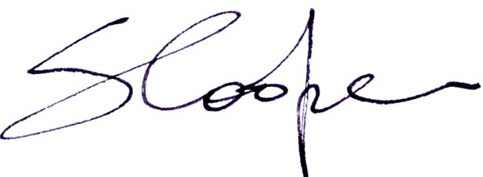

INSERT NAME HERE

attended the

**Westralian Indonesian Language Teachers’ Association**

**Term 1 Workshop 2017**

which involved professional learning for Indonesian teachers

addressing the TRBWA Professional Standards indicated

on

11 March 2017

0.5 days

at

School of Isolated and Distance Education (SIDE), Leederville

*Certificate of Participation*