Dear teachers,

Once again, it is with great pleasure that the WILTA committee extend an invitation to your school to participate in the fourth annual Kompetisi Klip-2; a YouTube video competition. The idea behind the competition is to engage students in language learning through ICT and to promote Indonesian to the community in a positive way.

This competition is open to students across both primary and secondary schools. With the rules outlined below:
- There are three student levels and six age groupings:
- Primary:
  - Kindergarten – Year 2
  - Year 3 – Year 4
  - Year 5 – Year 6
- Middle:
  - Year 7 – 8
  - Year 9 – 10
- Upper:
  - Year 11 – 12

- There are three categories:
- Bernyanyi E.g. a song sung by students in form of a music video or as a live performance; lip-syncing to own singing is allowed.
This category is open for the following age groups:
- Kindergarten – Year 2
- Year 3 – Year 4
- Year 5 – Year 6
- Year 7 – Year 8

- Bersandiwara E.g. a play, re-enactment, story or performance
This category is open for the following age groups:
- Year 3 – Year 4
- Year 5 – Year 6
- Year 7 – Year 8
- Year 9 – Year 10

- Berpidato E.g. formal speech in Indonesian on a topic of your choice
This category is open for the following age groups:
- Year 9 – Year 10
- Year 11 – Year 12

- The stipulation on group size and length of performance is as follows:
  - Bernyanyi: Maximum 35 students (Primary) and 2 – 6 students (Middle), performance length 2 – 3 minutes
  - Bersandiwara: 2 – 6 students, performance length 2 - 3 minutes
  - Berpidato: 1 student, performance length 2 - 3 minutes
- Each school may submit up to two videos for each category for each year group. Schools are encouraged to have their own vetting process prior to submission.
- Each video must contain official KK2 Intro and Outro, which are available in http://tinyurl.com/2019kk2
- Each video must be predominantly in Indonesian and produced by participants. All non-original work must be appropriately referenced.
- For Bernyanyi category, students and teachers will be responsible for checking copyright information for songs. Most songs are okay to be used on YouTube (as the account isn’t monetised). Details of how to check copyright information are available in this YouTube clip: https://www.youtube.com/watch?v=VmLl7FGNLo8
- Teachers will be responsible for seeking parental permission for any student whose face and/or name appears in the video. Specifically, parents will need to agree to their child’s face being published on YouTube. Teachers are also responsible for ensuring all rules are adhered to.
- Age restrictions apply to the oldest participating student. Age restrictions apply to who is speaking/singing in the videos for all age groups. For Middle School (Year 7 – 10) and Upper School (Year 11 – 12), the age restrictions also apply to production elements such as filming and editing. Teachers may assist with the language (all age groups) and the production elements (Middle School and Upper School) but cannot do it for the students. For Primary School, there are no restrictions on who can do the production elements, thus teachers may be solely or partly responsible for all recording and editing. The restrictions to 'number of participants' also applies to the production elements in Middle School and if the video wins, the prize money will be split evenly between all participants. For Berpidato category, it is okay for the sole participant to receive some help with filming, but the rest of the production elements and language should be done by themselves.

- Submissions will need to be received by 4pm on Wednesday, 26 June 2019. Details will be available soon on the WILTA website www.wilta.org .
- All winning entries from Kompetisi Klip2 2018 are available for sample at the following link https://www.youtube.com/watch?v=XvbmaP1YdRw&list=PLk5H_c3jmaVjuV8dPTEGo6JXWsIfBLjc5
(please note that the categories were slightly different in 2018)

Submission Process:
- Ensure you understand the rules of the competition.
- Create your videos.
- Download "KK2 Intro 2018" and "KK2 Outro 2018" from http://tinyurl.com/2019kk2 and add them to the beginning and end of each submission.
- Fill out the form, attached (one form per school).
- Submit your videos and form to WILTA. If you have multiple entries, make sure the file names match what is written on the form!
There are two ways that you can submit:
- Electronically:
Add your videos and scanned form to a Google Drive or Dropbox folder and share the folder with: kk2@wilta.org
- Post:
Send your form and USB Thumb Drive containing your videos to:
Kompetisi Klip-klip
37 Chalgrove Road, Madora Bay 6210

All videos will be published on YouTube over the mid-year school holidays and will be judged by a judging panel on two criteria: language use (includes meaning making, accuracy of pronunciation and grammar, appropriate for age level) and entertainment value (includes production elements and audience engagement, appropriate for age level).
Judging will be impartial. Judges' decision is final. Judges reserve the right to have 'no winner' in a category, if the category has no deserving winners.
Prizes have been very generously sponsored by the Indonesian government through the Education and Cultural Attaché of the Embassy in Canberra and the Consulate General in Perth, as follows:
- Bernyanyi
- Kindergarten – Year 2: $300 for Indonesian Department, to be spent on a reward for students
- Year 3 – Year 4 : $300 for Indonesian Department, to be spent on a reward for students
- Year 5 – Year 6 : $300 for Indonesian Department, to be spent on a reward for students
- Year 7 – Year 8 : $300 cash prize (split evenly)

- Bersandiwara
- Year 3 – Year 4 : $300 for Indonesian Department, to be spent on a reward for students
- Year 5 – Year 6 : $300 for Indonesian Department, to be spent on a reward for students
- Year 7 – Year 8 : $300 cash prize (split evenly)
- Year 9 – Year 10 : $300 cash prize (split evenly)

- Berpidato
- Year 9 – Year 10 (Winner): $300 cash prize for student
- Year 9 – Year 10 (Runner Up): $200 cash prize for student
- Year 11 – Year 12 (Winner): $300 cash prize for student
- Year 11 – Year 12 (Runner Up): $200 cash prize for student

- Overall Winners:
- Primary School : Additional $300 for Indonesian Department, to be spent on a reward for students
- Middle School : Additional $300 cash prize (split evenly)

Winners will be announced during Languages Week in Term 3.

Beginner editing tips
The following functions in iMovie are all you really need to make the most simple video:
- Import content
- Create a new file
- Add audio/video
- Detach audio from the video
- Trim the video clip
- Save/share project
Intermediate editing tips
When you have mastered the basics, try exploring your film editing program and experiment with the following functions (use “Help” to learn more or search for a tutorial online):
- Add credits or titles to put text over the top
- Add transitions between the video clips
- Split clip to cut the clip to delete or edit a subsection
- Slow motion/fast forward (look for the turtle/rabbit icon)
- Crop to resize the screen area
- Ken Burns effect to create a zoom in / zoom out or panning post-filming
- Green/blue screen to overlay two video clips (requires understanding of green screening technique)
- Side by side and picture in picture to have two video clips playing at the same time
- Instant replay and rewind (look under the ‘modify’ tab)
- Add maps, backgrounds or your own images

Written by Kate Reitzenstein, AISWA,
For WILTA Term 1 Workshop 2016)
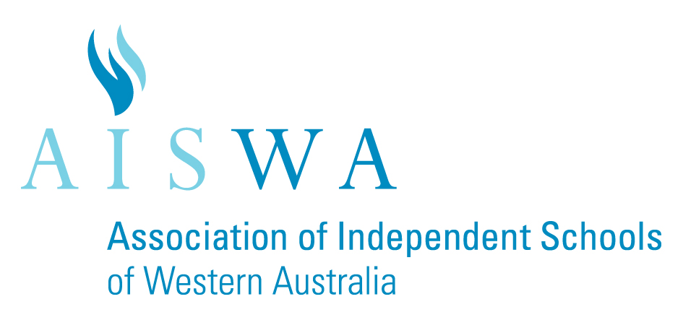
SUBMISSION FORM
Guidelines: | Each submission must  - Adhere to the rules of Kompetisi Klip-2  - Be submitted to WILTA with this submission form (one form per school).
Application Date: | All submissions must be received by 4 pm on Wednesday, 26 June 2019.
Important Notes: | - There should be no more than 2 submissions per category per age group.  - Submission can be cancelled if video clip is proven to be plagiarised.

Name of School:
Age group | Category of Competition | Number of participants | Title of video(s)
Kindy – Year 2  No one older than Year 2 may be in the performance. | Bernyanyi |  | 1.
 |  |  | 2.
Year 3 – Year 4  No one older than Year 4 may be in the performance. | Bernyanyi |  | 1.
 |  |  | 2.
 | Bersandiwara |  | 1.
 |  |  | 2.
Year 5 – Year 6  No one older than Year 6 may be in the performance. | Bernyanyi |  | 1.
 |  |  | 2.
 | Bersandiwara |  | 1.
 |  |  | 2.
Year 7 – Year 8  No one older than Year 8 may be in the performance or play any part in the creative process (including translation if applicable, recording and editing). | Bernyanyi |  | 1.
 |  |  | 2.
 | Bersandiwara |  | 1.
 |  |  | 2.
Year 9 – Year 10  Same restrictions as above. | Berpidato |  | 1.
 |  |  | 2.
 | Bersandiwara |  | 1.
 |  |  | 2.
Year 11 – Year 12  Same restrictions as above. | Berpidato |  | 1.
 |  |  | 2.

Pto.

Declaration
- All submissions comply with the rules of KK2 and contain official KK2 Intro/Outro.
- Parental permission has been received from all students featured in the video(s) submitted.
- We have checked and abided by copyright restrictions in the video(s) submitted.

Signature of teacher in charge: ___________________________________
Name of teacher in charge: ___________________________________
Email address: ___________________________________
Date signed: ___________________________________

Dear Parents and Caregivers,
Your child is interested in playing a part in a YouTube video competition, Kompetisi Klip-2, which is an initiative of WILTA. The competition is intended to build Indonesian language literacy and ICT skills, as well as motivate students and further their interest in Indonesian culture by creating and recording a musical performance, story or scene re-enactment, or a speech. Students will create a video of themselves and/or classmates in a re-enactment or performance in Indonesian. Students will create their videos at school and then the best will be selected to enter the competition. If your child’s video is selected it will be published on YouTube for public viewing.
We require parental permission before submission to show your child’s face in this public forum. If you do not wish your child’s face to be shown they are still able to participate in the process by helping with preparation, filming and editing.
Cost: Nil
Please sign and return the attached consent form so that your child can commence their involvement in planning the performance by ________________________________.
Salam hangat,

--------------------------------------------------------------------------------------------------------------------------
I _____________________________ hereby give consent for my child ___________________________
to be filmed for Kompetisi Klip-2. I acknowledge that my child’s video may be selected for the inter-school competition whereby their video will be published on YouTube and my child may be recognised. This video may be selected to be shown in a public forum if it wins the competition and images from the video may be used for promotional purposes.
Signed: ____________________________Date:________________________________

